**Problem 1**

* **Initial ERD:**

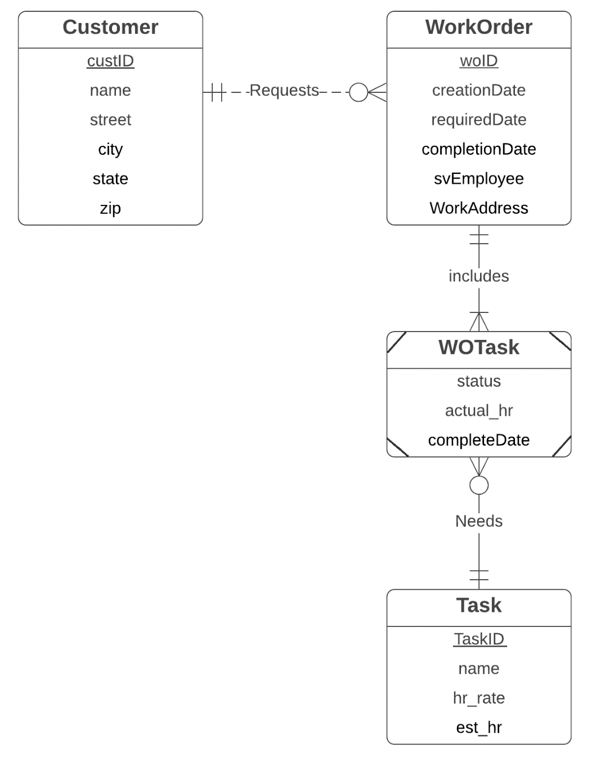

* **Revised ERD:** 